**A STUDENT INDUSTRIAL WORK EXPERIENCE**

**SCHEME (SIWES) TECHNICAL REPORT**

**UNDERTAKING AT**

**FEDERAL UNIVERSITY OF PETROLEUM RESOURCES EFFURUN**

**BY**

**OGBODOGBO FORTUNE ONAJITE**

**COS/10169/2022**

**SUBMITTED TO THE DEPARTMENT OF COMPUTER SCIENCE**

**FEDERAL UNIVERSITY OF PETROLEUM RESOURCES EFFURUN**

**P.M.B. 1221, EFFURUN, DELTA STATE, NIGERIA.**



**IN PARTIAL FUFILMENT OF THE REQUIREMENT FOR THE AWARD OF BACHELOR OF SCIENCE DEGREE (B.SC)**

**IN**

**COMPUTER SCIENCE**

**2024/2025 ACADEMIC SESSION**

**DECEMBER 2025**

# **CERTIFICATION**

This is to certify that this report was carried out and submitted by **Ogbodogbo Fortune Onajite**, with Matriculation Number **COS/10169/2022**, in partial fulfilment of the requirements for the award of the Bachelor of Science (B.Sc.) degree in **Computer Science** at the **Federal University of Petroleum Resources, Effurun (FUPRE)**.

The industrial attachment took place at the**Software & Hardware Lab, Federal University of Petroleum Resources, Effurun**, from **23rd June to 5th December, 2025**.

This work is original and has not been submitted elsewhere for any academic or professional qualification. All sources used have been duly acknowledged.

_____________________________ ____________________  
OGBODOGBO FORTUNE ONAJITE Date  
COS/10169/2022

__________________________ ____________________  
MR. REUBEN ABERE MBONU Date  
*Head of Department* & SWIES Supervisor  
*Computer Science*

# **DEDICATION**

This report is dedicated to Almighty God for His guidance, strength and protection throughout my six-month industrial training. It is also dedicated to my family for their unwavering support, encouragement and belief in my growth, and to my friends and colleagues who made this journey enriching and memorable.

# **ACKNOWLEDGEMENTS**

I wish to express my sincere gratitude to everyone who supported and guided me during my SIWES attachment. First and foremost, I give thanks to God Almighty for keeping me in good health and granting me the opportunity to complete this training.

My special thanks go to my supervisor, **Mr. Efue Elohozino**, for his invaluable guidance, patient mentorship and constructive feedback throughout the internship. I am grateful to the Head of Department, the SIWES coordinators and the staff of the Software & Hardware Lab at the Federal University of Petroleum Resources, Effurun, for providing access to facilities, mentorship and an enabling environment for learning.

I would also like to thank my colleagues and fellow trainees for the collaborative spirit, peer support and the knowledge-sharing that made many tasks easier and more instructive. Finally, I appreciate my family and friends for their encouragement, and everyone—named and unnamed—who helped me acquire the practical skills documented in this report.

# **TABLE OF CONTENTS**

**CERTIFICATION** ii

**DEDICATION** iii

**ACKNOWLEDGEMENTS** iv

**TABLE OF CONTENTS** v

**TABLE OF FIGURES** vi

**CHAPTER ONE** 1

1.1 Background of SIWES 1

1.2 The Industrial Training Fund (ITF) / University SIWES Unit 1

1.3 Aims and Objectives of SIWES 2

1.4 Importance of SIWES to Computer Science Students 3

1.5 Scope, Duration and Placement Details 4

**CHAPTER TWO** 6

2.1 Software Tools Utilized During My Internship 6

**2.2 Web Technologies Utilized During My Internship** 13

**2.3 Skills Acquired During My Internship** 16

**CHAPTER THREE** 19

3.1 Major Project — Real-time Chat Application 19

3.2 Other Project Summaries (mini-projects & utilities) 29

CHAPTER FOUR 34

4.1 Hardware Tasks & PC Assembly 34

4.2 Networking Practicals 39

4.3 Embedded Systems Introduction & IoT Basics 43

4.4 System Maintenance & Security Basics 46

**CHAPTER FIVE** 50

5.1 Challenges Faced 50

5.2 Suggestions for Improvement of SIWES 51

5.3 Conclusion 52

**TABLE OF FIGURES**

Figure 1: Visual Studio Code 6

Figure 2: Google Chrome 7

Figure 3: GitHub 8

Figure 4: Postman 9

Figure 5: Windows Command Line 10

Figure 6: MYSQL Workbench 11

Figure 7: MongoDB Atlas 11

Figure 8: Render 12

Figure 9: Vercel 13

Figure 10: Application architecture diagram 16

Figure 11: Real Time app architecture 20

Figure 12: User Document Example 21

Figure 13: Message Document Example 21

Figure 14: Token Validation middleware 22

Figure 15: Online users implementation 23

Figure 16: Message Event Snippet 24

Figure 17: Notification UI 25

Figure 18: Render Dashboard with Real time app 27

Figure 19: BMI Flask Form UI 30

Figure 20: BMI Calculator code 31

Figure 21: Todo web UI 32

Figure 22: Todo fetch snippet 33

Figure 23: Internal PC Components 35

Figure 24: Motherboard F-Panel Pin 37

Figure 25: Bulging Capacitors 39

Figure 26: Network Topologies 41

Figure 27 :ifconfig output 43

Figure 28: Arduino Uno and ESP32 pinouts 45

Figure 29: LED Blink Program 46

Figure 30: Disk Management Tool 47

Figure 31: Firewall Functions 49

# **CHAPTER ONE**

## 1.1 Background of SIWES

The Student Industrial Work Experience Scheme (SIWES) is a skills-based training program designed to expose university students to the practical aspects of their course of study. SIWES was established to bridge the gap between theoretical knowledge acquired in the classroom and the practical skills required in the workplace. The program places students with host organizations where they engage in supervised hands-on activities relevant to their discipline. For students in science and technology fields — including Computer Science — SIWES provides an invaluable opportunity to apply academic principles to real-world problems, develop technical competencies, and observe professional working environments.

## 1.2 The Industrial Training Fund (ITF) / University SIWES Unit

The Industrial Training Fund (ITF) and the University SIWES Unit jointly oversee the administration and coordination of SIWES placements. The ITF provides policy guidance, supports industry linkages, and, where available, offers financial assistance or stipends to trainees. The University SIWES Unit is responsible for registering students for placement, coordinating with host organizations, monitoring trainees’ progress, and ensuring compliance with SIWES guidelines.

## 1.3 Aims and Objectives of SIWES

The principal aim of SIWES is to provide students with practical industrial exposure that complements their academic training. The program seeks to produce graduates who are technically competent, professionally disciplined, and ready to meet the demands of industry. More specifically, this SIWES placement pursued the following objectives:

1. To expose the trainee to practical aspects of computer science and information technology, including software development, system administration, networking, database management and basic embedded systems.
2. To enable the application of theoretical knowledge (from coursework) in real work situations and projects.
3. To develop practical skills in programming, debugging, deployment, hardware assembly and network troubleshooting.
4. To instill professional workplace behaviors, including communication, teamwork, time management and adherence to workplace safety.
5. To encourage independent problem solving and continuous learning through on-the-job challenges and mentorship.
6. To compile a thorough technical report and logbook that documents the trainee’s learning, projects and reflections.

These objectives guided the training activities and the evaluation criteria used by the host supervisors and the University SIWES Unit.

## 1.4 Importance of SIWES to Computer Science Students

SIWES is especially important for Computer Science students because it translates abstract concepts into practical competence. Theoretical modules such as Algorithms, Data Structures, Operating Systems, Database Management and Networking are best learned when applied to real systems. The benefits of SIWES for Computer Science trainees include, but are not limited to:

* **Practical application of coursework:** Implementing algorithms, writing production-like code, and deploying services makes theoretical material tangible and easier to master.
* **Exposure to real development workflows:** Using version control (Git/GitHub), code review, issue tracking and deployment practices prepares students for professional software engineering environments.
* **Systems and operations experience:** Working with Linux, shell scripting, server processes, and basic system administration improves an understanding of how software runs in production.
* **Networking and hardware literacy:** Basic network configuration, use of diagnostic tools, and PC assembly give a fuller appreciation of the hardware and network layers that software relies upon.
* **Soft-skill development:** Team communication, reporting, time management, and professional etiquette learned on placement are as valuable as technical skills in career success.
* **Problem-solving in ambiguous contexts:** Industry problems are often not well-specified; SIWES teaches how to reverse-engineer requirements, debug distributed systems, and verify fixes under constraints.

Altogether, the SIWES experience helps produce graduates who are more immediately productive, safer to onboard, and better able to contribute to technical teams.

## 1.5 Scope, Duration and Placement Details

**Scope:**  
The scope of this training covered multiple areas of information technology as practiced in an academic Lab. Major activity domains included: software development and web technologies (frontend and backend), database management (SQL and NoSQL), caching/presence patterns (Redis), real-time systems (Socket.IO), deployment and operations (Linux, process management, Render hosting), networking fundamentals, basic embedded/IoT prototyping and computer hardware maintenance. The training emphasized both short practical projects (mini utilities, scripts) and a major project (a real-time chat application), plus routine systems maintenance assignments.

**Duration:**  
The attachment commenced on **23rd June 2025** and concluded on **5th December 2025**, spanning approximately six months. During this period, training activities were scheduled across weekdays with an organized weekly routine that combined supervised lessons, practical lab exercises, and independent project work.

**Placement Details:**

* **Host Unit:** Software & Hardware Lab, Federal University of Petroleum Resources, Effurun (FUPRE).
* **Supervisor:** Mr. Efue Elohozino.
* **Key responsibilities performed:** participating in web development tasks, designing and implementing a real-time chat application, writing Python utilities (e.g., BMI calculator, log parser), performing PC assembly and troubleshooting, learning embedded systems basics (ESP32 / Arduino blink and PIR reading), and assisting in network diagnostic activities.
* **Work pattern:** mixture of guided sessions (demonstrations and supervised practice) and independent tasks with progress reports and logbook updates. Weekly logbook entries documented day-to-day activities, practical results, and learning reflections.

# **CHAPTER TWO**

## 2.1 Software Tools Utilized During My Internship

**Visual Studio Code (VS Code)**

Visual Studio Code (VS Code) is a lightweight yet powerful open-source code editor developed by Microsoft. It supports numerous programming languages and frameworks, and offers intelligent features such as IntelliSense, built-in debugging, integrated terminal, and seamless Git/GitHub integration. Its rich extension marketplace allowed me to install tools for JavaScript, Python, React, Node.js, and database management, making it my primary development environment throughout the internship.

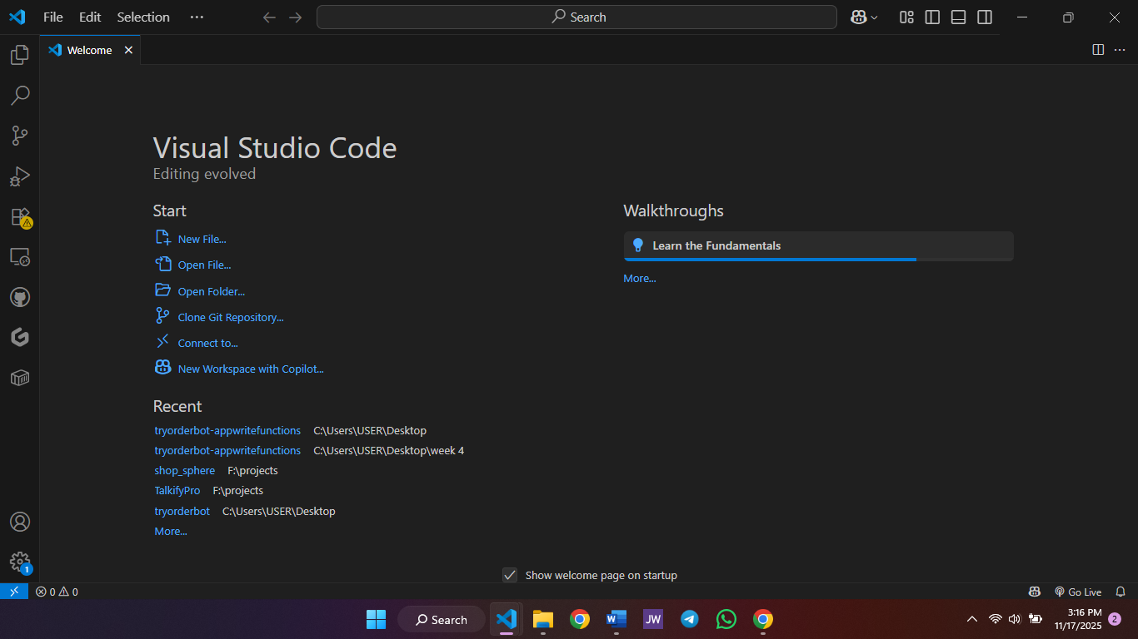

Figure 1: Visual Studio Code

**Google Chrome**

Google Chrome served as my main web browser and testing environment for frontend and backend applications. Its built-in Developer Tools—such as the Elements panel, Console, Network monitor, and Lighthouse—enabled efficient debugging, performance auditing, and DOM inspection. Chrome streamlined my workflow by allowing quick local testing, responsive design simulation, and API endpoint verification.

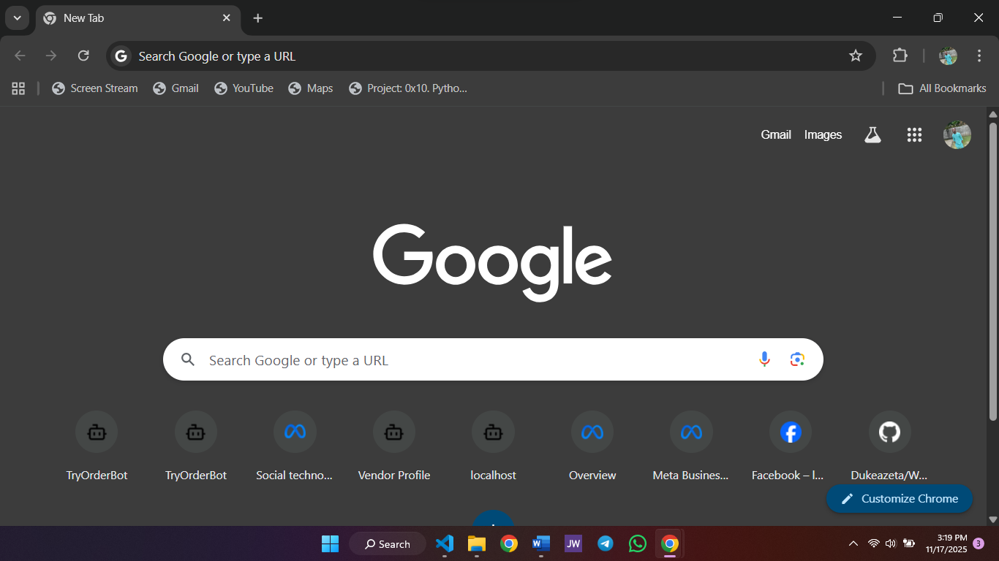

Figure 2: Google Chrome

**GitHub**

GitHub is a cloud-based platform for version control and collaborative software development. It enabled me to manage repositories, track changes, create branches, and collaborate through pull requests. During the internship, GitHub played a key role in hosting project codebases, reviewing changes, managing issues, and ensuring coordinated development through Git workflows.

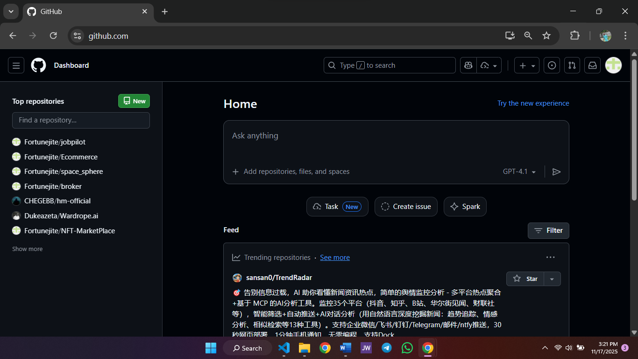

Figure 3: GitHub

**Postman**

Postman is an API development and testing platform that helps developers build, test, and debug APIs efficiently. During the internship, it was used to test RESTful APIs built with Node.js and Python, validate request and response data, simulate authentication, and troubleshoot backend logic. Its visualization, monitoring, and test automation features made it an essential tool for backend development and debugging.

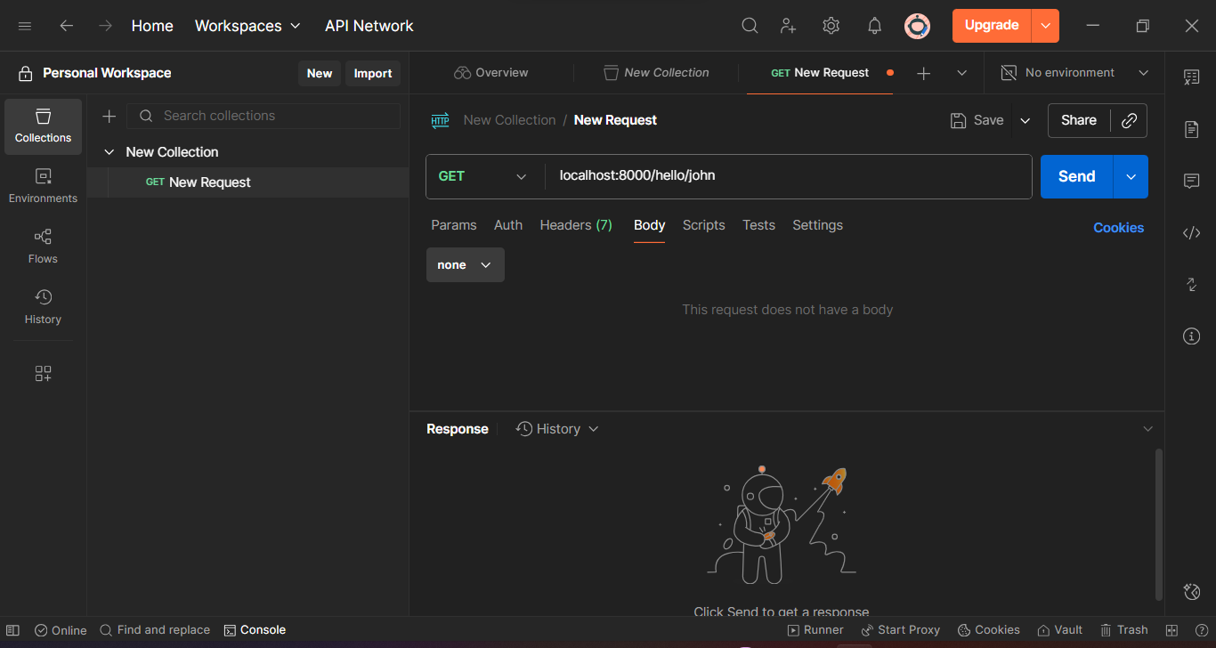

Figure 4: Postman

**Windows Command Line (Command Prompt)**

The Windows Command Prompt was used for executing essential system-level and development commands during my internship. It provided quick access to tools like Git, Node.js, and Python, and facilitated file navigation, environment configuration, and running scripts. The command-line interface improved my efficiency, especially when installing packages, testing scripts, or interacting with local servers.

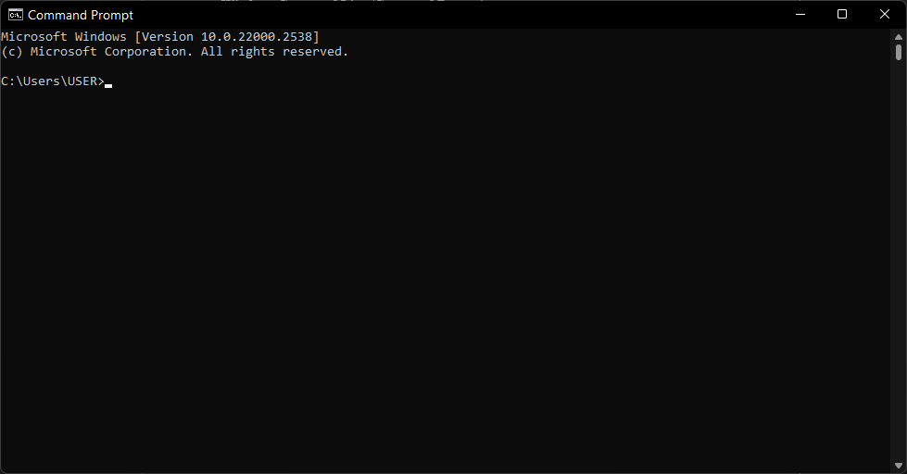

Figure 5: Windows Command Line

**MySQL Workbench**

MySQL Workbench is a graphical tool developed by Oracle for designing, querying, and managing MySQL databases. I used it for creating schemas, writing SQL queries, testing database interactions, and visualizing relationships between tables. Its intuitive interface made database administration tasks such as backups, imports, and user management straightforward and efficient.

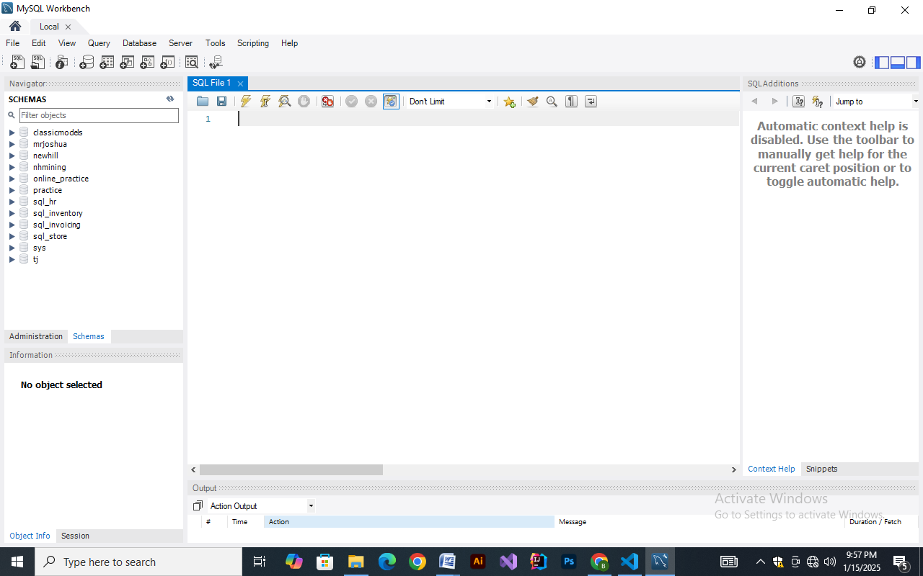

Figure 6: MYSQL Workbench

**MongoDB Atlas**

MongoDB Atlas is a cloud-based fully managed database service for running MongoDB deployments. It simplified database hosting, monitoring, and scaling, enabling me to store and retrieve application data reliably. I used Atlas for managing collections, querying documents, creating indexes, and integrating my Node.js backend with the database through environment-protected connection strings.

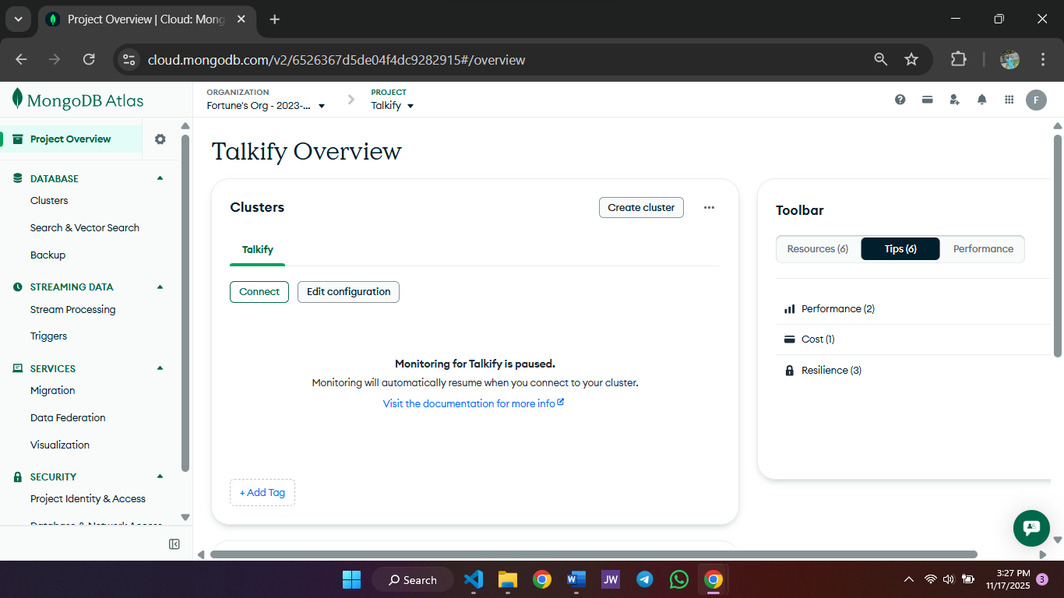

Figure 7: MongoDB Atlas

**Render**

Render is a modern cloud hosting platform used for deploying web services, servers, and databases. During my internship, I used Render to host backend applications, test APIs, and manage continuous deployments. It provided features such as automatic builds from GitHub, environment variable configuration, and service monitoring—allowing smooth deployment of Node.js and Python services.

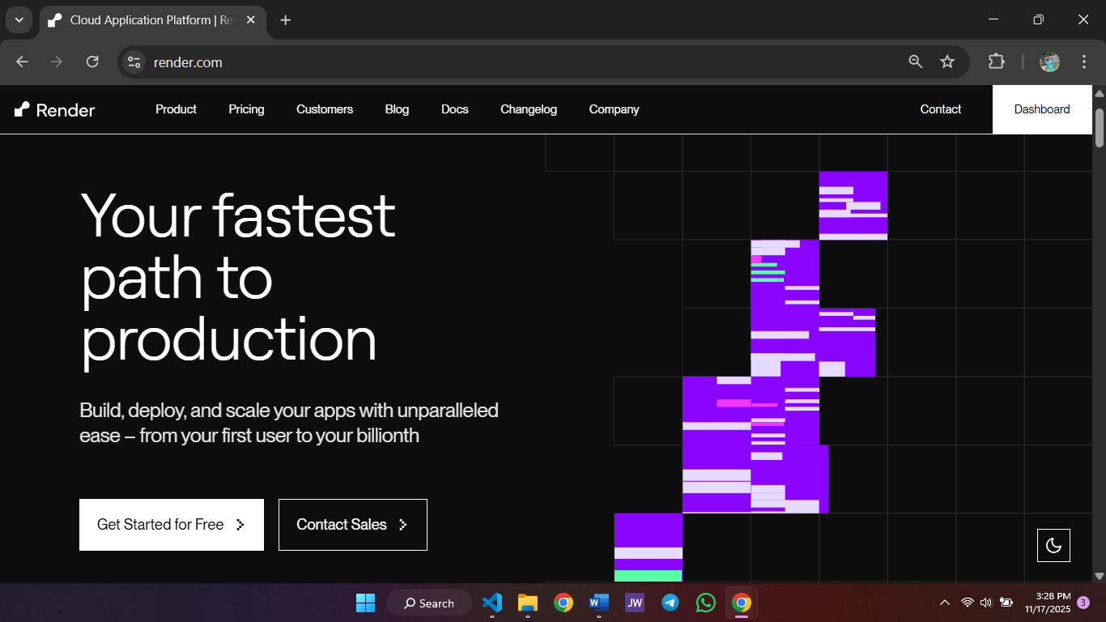

Figure 8: Render

**Vercel**

Vercel is a high-performance cloud platform optimized for frontend frameworks such as React and Next.js. I used it to deploy frontend interfaces and static sites quickly and securely, benefiting from its fast global CDN and intuitive Git-based deployment workflow. Vercel enabled me to preview frontend changes, share live deployments with supervisors, and validate user interfaces on multiple devices.

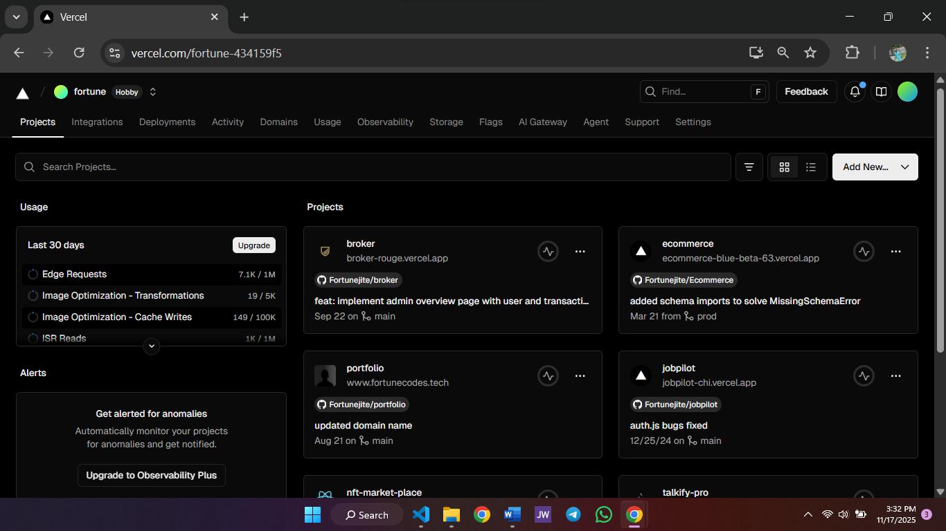

Figure 9: Vercel

**2.2 Web Technologies Utilized During My Internship**

During the attachment I worked with a wide range of web technologies spanning frontend, backend, databases, and developer tooling. The stack I used reflects common modern web patterns (component-based frontends, REST/real-time backends, and a combination of relational and NoSQL stores) and was applied directly in the projects I contributed to—most notably the real-time chat application, and several small utilities.

**Frontend**

**HTML & CSS** — HTML provided the document structure for every page I built or edited, while CSS (vanilla and utility-first patterns) handled presentation and responsive layout. I used semantic HTML for accessibility and SEO, and employed CSS Grid/Flexbox along with simple utility classes to ensure UIs adapted across desktop and mobile.  
**JavaScript** — JavaScript brought interactivity to pages: DOM updates, event handling, form validation, and AJAX calls for asynchronous behavior. I used the browser DevTools extensively to debug scripts and inspect network activity.  
**React** — For component-based interfaces I used React to break the UI into reusable parts. React’s state and effect hooks simplified UI state management (local state, effect-driven data fetching) and made it straightforward to integrate real-time events from Socket.IO into the view layer.

**Backend**

**Python & Flask** — I used Python for scripting and small automation; Flask was the framework of choice for lightweight HTTP endpoints. With Flask I built simple APIs and prototyped services (e.g., demo endpoints for parsing logs and for quick proof-of-concept features).  
**Node.js & Express** — For the production-facing real-time backend I used Node.js with Express. Express provided a minimal and flexible routing layer for REST endpoints (user management, friend requests, chat history) while Socket.IO on top of Node handled real-time socket communication. Express middleware patterns (authentication checks, JSON parsing, error handling) were applied consistently across routes.

**Databases and Caching**

**MySQL** — I used MySQL where relational integrity and structured reporting were important (e.g., administrative tables and some analytic exports). MySQL Workbench helped with schema design, querying and visualizing table relationships.  
**MongoDB (Atlas)** — For flexible document storage that do not strictly conform to rigid schemas, I used MongoDB Atlas. Storing messages and embedded media metadata in documents simplified retrieval of conversation histories.  
**Redis** — Redis served as an in-memory cache and light-weight session/presence store. It was useful for caching auth/session details, and implementing simple job queues during testing (LPUSH/BRPOP patterns). Redis greatly reduced database load for high-frequency reads (presence lookups, unread counts).

**Developer & System Tools**

**Git & GitHub** — Version control with Git was central to collaboration: branching for features, meaningful commit messages, pull requests and code review workflows on GitHub. I used GitHub to host code, manage issues, and coordinate merges with supervisors.  
**Linux & Command Line** — Linux was the primary server environment; familiarity with the shell (bash), process management (PM2), package managers (apt, npm), and log inspection was essential for deployments and troubleshooting. I automated routine tasks with small shell scripts and used SSH to manage remote servers.

**How these technologies fit together (summary):** the frontend (HTML/CSS/JS/React) delivered an interactive user experience, calling backend APIs (Express/Flask) for persistent operations and subscribing to real-time events via Socket.IO. Persistent data lived in MongoDB/MySQL depending on structure and query patterns, while Redis provided fast ephemeral storage for sessions and presence. Git + GitHub and Linux-based servers were used to manage code and deploy services (development → staging → preview), completing the full development lifecycle from local prototypes to hosted demos.

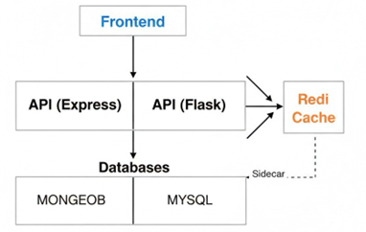

Figure 10: Application architecture diagram

**2.3 Skills Acquired During My Internship**

During the six-month attachment I developed a balanced mix of technical abilities and professional (soft) skills. The projects and daily tasks pushed me to apply classroom theory to real problems, and the following sections summarize the most important skills I acquired and how I used them in practice.

**Technical skills**

**Problem-solving & analytical thinking —** I learned to break down complex problems into smaller, testable pieces. For example, when duplicate messages appeared during socket reconnections in the chat app, I methodically traced the event flow, reproduced the bug, and implemented idempotent message-handling and reconnection guards to prevent re-delivery. This taught me to form hypotheses, design simple experiments, and verify fixes.

**Thinking like a programmer —** I improved at translating requirements into algorithms and data structures suitable for production. Designing chat room identifiers, choosing document vs relational models for message history, and deciding where to cache presence data (Redis) required thinking about performance, consistency and trade-offs. These design decisions became routine as I gained experience.

**Debugging & diagnostics —** I practiced systematic debugging across the stack: using browser DevTools and network logs for frontend issues; inspecting server logs, Node stack traces and Redis keys for backend problems; and using shell tools (grep, tail, journalctl) on Linux servers for deployment issues. A memorable case was resolving an intermittent token-validation error by reproducing the request flow, checking token expiry/refresh logic, and adding better logging to capture the root cause.

**Testing, version control & CI basics —** I wrote small unit tests and manual integration checks for critical functions (auth, message persistence), used Git for branching and pull-request based review, and experimented with simple GitHub workflow automation to run linting or basic checks on push. This improved code quality and made collaboration safer.

**Professional / transferable skills**

**Communication & teamwork —** Working with supervisors and peers taught me to present progress clearly, ask concise questions, and document assumptions. Regular demo sessions and code reviews improved my ability to explain technical decisions to both technical and non-technical audiences.

**Time management & prioritization —** Balancing multiple small projects, system maintenance tasks and learning objectives required planning and prioritizing. I learned to estimate effort, break work into milestones (e.g., implement X by week Y), and communicate delays early to supervisors.

**Adaptability & continuous learning —** The internship exposed me to many unfamiliar tools and problems (Redis patterns, Socket.IO edge cases, Linux server ops). I became comfortable searching documentation, testing quick prototypes, and learning on-the-job—which is vital for software roles where stacks evolve rapidly.

**Professionalism & workplace discipline —** I adopted best practices for workplace conduct: maintaining accurate logbook entries, following safety guidelines for hardware handling, and respecting confidentiality and institutional policies.

# **CHAPTER THREE**

## ****3.1 Major Project — Real-time Chat Application****

The major software project I developed during my SIWES training was a **real-time chat application**. The goal of this project was to build a functional messaging system that allows users to register, log in, send and receive messages in real-time, manage friend requests, create group chats, and interact through a clean Nunjucks-powered interface. This project strengthened my backend engineering, real-time communication, API design, and system design skills.

**PRIMARY OBJECTIVES**

* Build a fully functional real-time messaging system.
* Implement one-to-one chat and group chat.
* Allow users to send and accept friend requests.
* Enable profile viewing.
* Improve development skills in Express, MongoDB, Redis, and Socket.IO.

**FUNCTIONAL REQUIREMENTS**

* User authentication with token verification.
* Friend request workflow (send, cancel, accept, decline).
* Group chat creation and membership management.
* Text messaging.
* In-app notifications for friend request.

**NON-FUNCTIONAL REQUIREMENTS**

* Low-latency message delivery.
* Efficient token verification using Redis.
* Clear UI rendered through Nunjucks templates.
* Smooth deployment on the Render platform.

**SYSTEM ARCHITECTURE OVERVIEW**

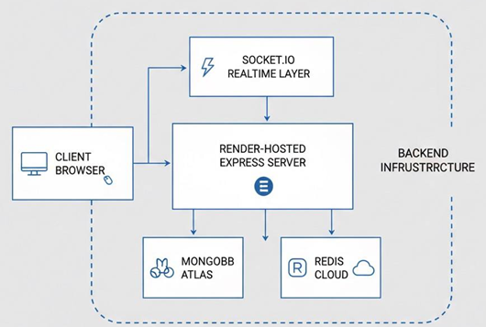

Figure 11: Real Time app architecture

**ARCHITECTURE SUMMARY**

* **Frontend**: Nunjucks templates rendered by Express.
* **Backend**: Node.js + Express handling API routes and page rendering.
* **Realtime Engine**: Socket.IO responsible for messaging, presence, and notifications.
* **Database**: MongoDB for users, chats, messages, notifications, and friend requests.
* **Cache**: Redis used only to store authentication tokens.
* **Deployment**: Application hosted on **Render**, scaled automatically.

**CORE COLLECTIONS**

**Users**

Stores all user profile information including avatar.

#### 

Figure 12: User Document Example

**Messages**

**Stores all the messages for a user**

#### 

Figure 13: Message Document Example

**AUTHENTICATION DESIGN**

**Login Flow**

* User logs in → server validates credentials.
* Server generates a token (UUID) and stores it in Redis
* Token is attached to **every URL** (e.g., /?token=abc123).

**Token Verification**

* On any API hit or WebSocket handshake:
  + Extract token from URL.
  + Compare with Redis-stored token value.
  + If exists → allow user access.

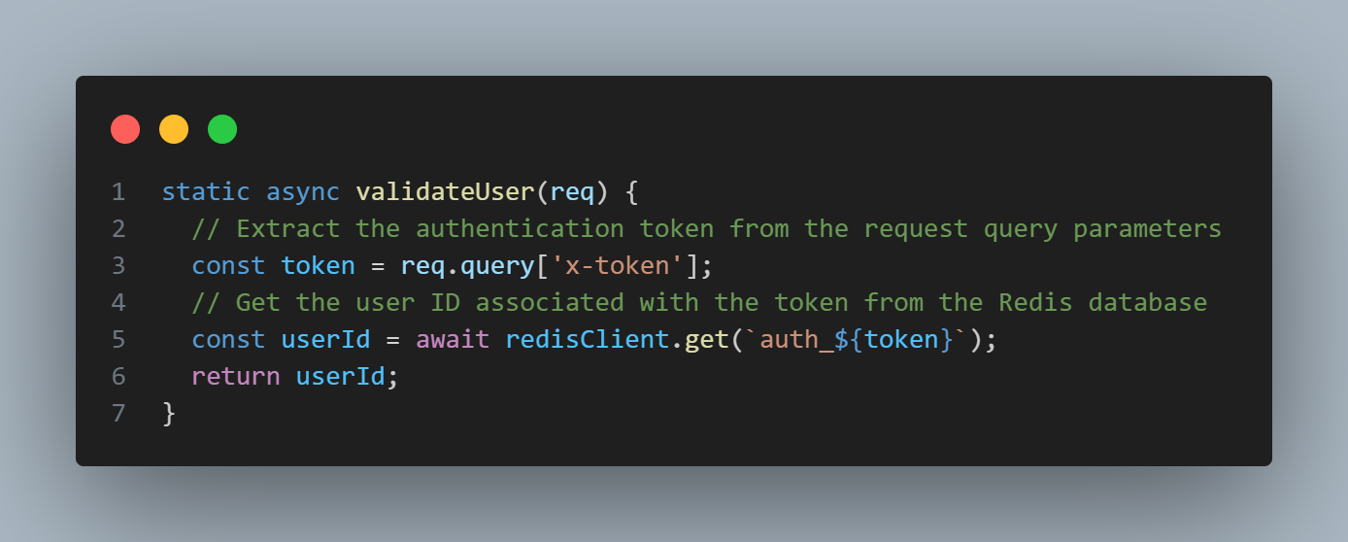

Figure 14: Token Validation middleware

**Realtime Communication (Socket.IO)**

* **Tracking Online Users**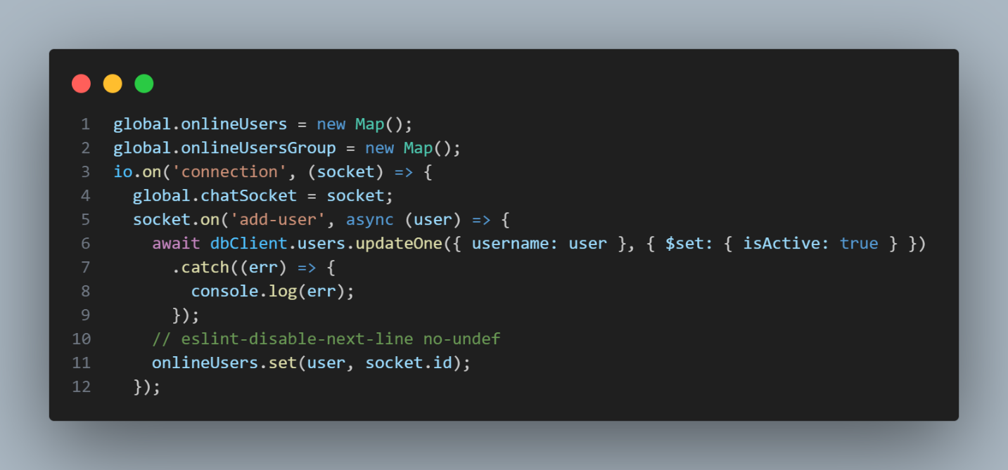

Figure 15: Online users implementation

This allowed me to:

* Check if a user is online
* Send messages directly to specific users
* Emit notifications immediately

**Real-time Message Flow**

1. Client emits send_msg.
2. Server validates chat membership.
3. Save message to MongoDB.
4. Emit message to all members of that chat room.
5. If receiver is online → deliver instantly using their socket ID.
6. If offline → they’ll get the messages when they reconnect.

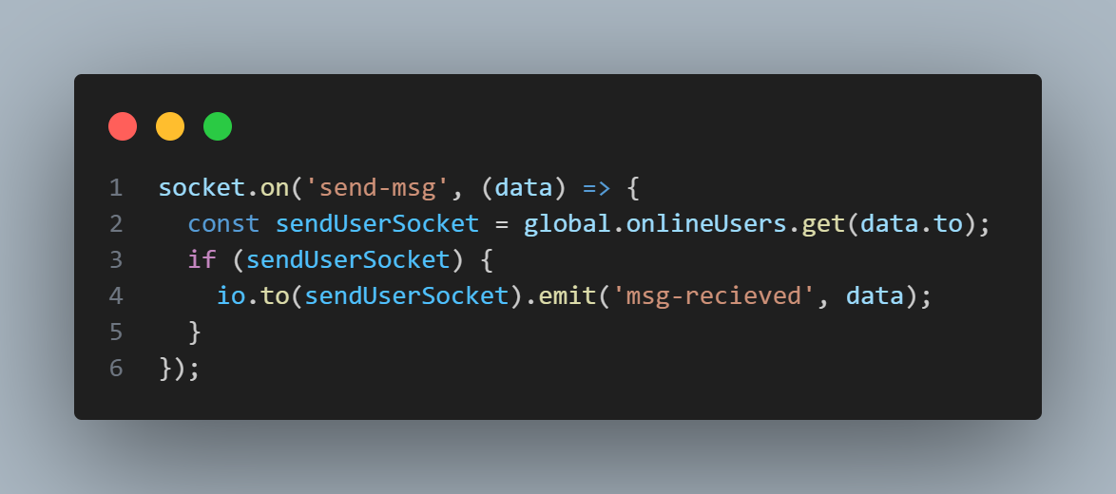

Figure 16: Message Event Snippet

**Friend Requests & In-App Notifications**

**Friend Requests**

* Stored in MongoDB
* Notifications also stored in MongoDB
* Realtime updates handled through Socket.IO

**Notification Flow**

1. User A sends request to User B.
2. MongoDB stores the request.
3. Notification record created.
4. If User B is online, emit notification event
5. If offline → user sees it later in menu.

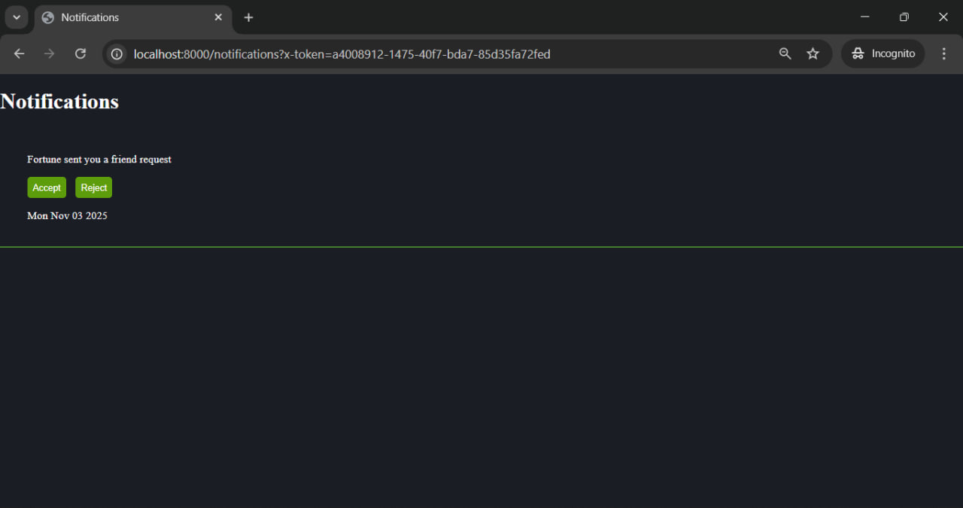

Figure 17: Notification UI

**MEDIA HANDLING (IMAGE UPLOADS)**

I implemented:

* multipart/form-data upload
* Convert uploaded image to Buffer
* Store buffer directly in MongoDB document

**Why this was chosen**

* Simplest solution during training
* No need for S3 or cloud storage
* Atomic: media + message saved together

**Trade-offs**

* DB size increases faster
* Backup time increases
* File retrieval is slower than CDN

**DEPLOYMENT ON RENDER**

The application was deployed on **Render**, which handled:

* Server hosting
* Automatic restarts
* Environment variables
* SSL certificate provisioning
* WebSocket compatibility out of the box

**Basic Flow:**

1. Push code to GitHub
2. Render auto-deploys
3. Build command: npm install
4. Start command: npm start

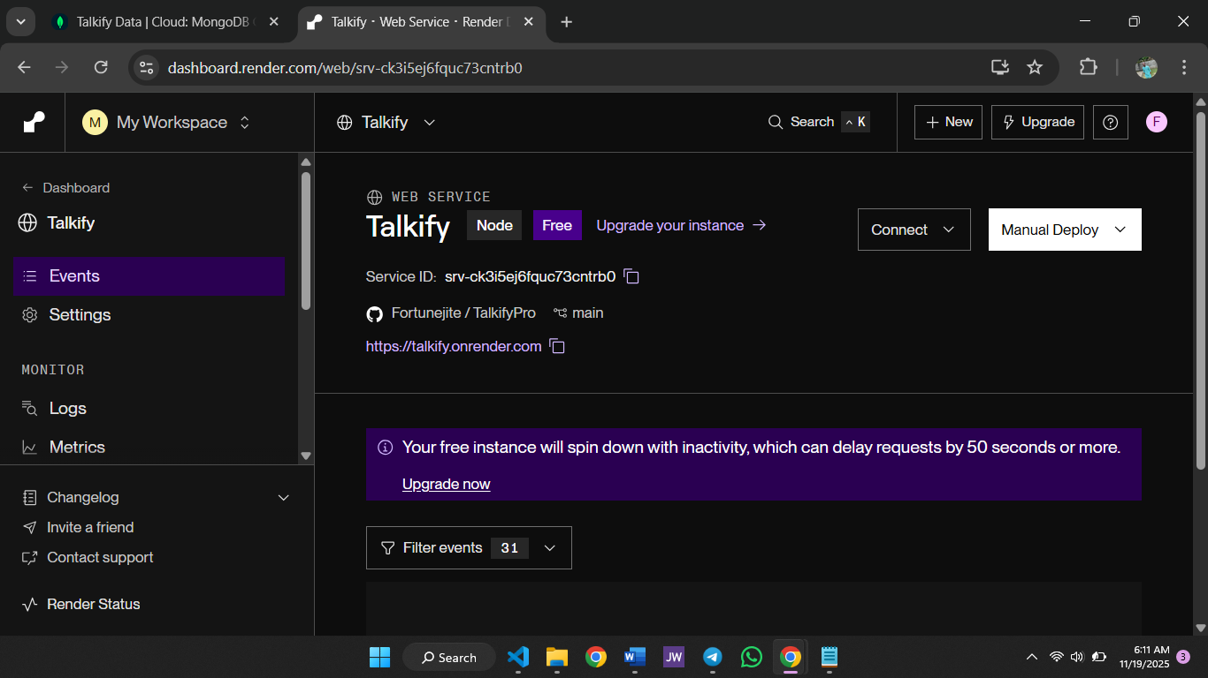

Figure 18: Render Dashboard with Real time app

**CHALLENGES ENCOUNTERED & SOLUTIONS**

**1. Image Handling**

**Challenge:** Where to store images  
**Solution:** Stored as Buffer in MongoDB directly  
**Lesson:** For large-scale apps, use cloud storage

**2. Token Persistence**

**Challenge:** How to preserve authentication across browser refresh  
**Solution:** Attach token to every URL  
**Lesson:** In production, tokens should be stored in cookies/local storage with safer patterns

**3. Real-time Duplication Issues**

**Challenge:** Duplicate messages during reconnection  
**Solution:** Implemented server-side deduplication by storing message IDs  
**Lesson:** Idempotency is essential in realtime systems

**4. Render Deployment Issues**

**Challenge:** WebSocket disconnects  
**Solution:** Configure consistent environments and test repeatedly  
**Lesson:** Each hosting platform behaves differently with sockets

**SUMMARY OF THE PROJECT**

This project significantly strengthened my skills in:

* Backend development with Express
* Realtime communication using Socket.IO
* MongoDB modeling and optimization
* Redis caching patterns
* Managing user presence
* Handling media uploads
* Deploying production-like applications

It remains the most technically challenging and rewarding project I built during my SIWES program.

## 3.2 Other Project Summaries (mini-projects & utilities)

During my SIWES attachment I completed several smaller projects and utilities alongside the major realtime application. These mini-projects were intentionally compact so I could practice a variety of skills — scripting in Python, small web UIs, Git workflows, and automation — and each contributed lessons about design, testing and maintainability. Below I summarize the most important mini-projects, describe their purpose, technology stack and key implementation notes, and list practical lessons learned from each.

**BMI CALCULATOR**

**Objective:**  
Provide a quick, reliable tool to compute Body Mass Index (BMI) for demonstration and learning purposes.

**Tech / Tools:**  
Python, simple CLI (stdin/stdout), Flask wrapper for a web UI.

**Implementation & Features:**

* A small Python script that reads weight and height from stdin, validates input (numeric, non-zero), computes BMI = weight(kg) / height(m)\², and prints the BMI value with a simple category (Underweight / Normal / Overweight / Obese).
* Implemented parameterized functions (def compute_bmi(weight, height): return bmi) and modular code to make unit testing trivial.
* Added a lightweight Flask wrapper in one iteration to make the tool accessible via a browser form and to practice basic HTTP endpoints.

**Testing & Validation:**

* Unit tests covered boundary conditions (zero/negative inputs) and string-to-float parsing.
* Manual test cases confirmed correct categorization.

**Lessons learned:**

* Importance of input validation and clear error messages.
* How to quickly convert a CLI utility to a minimal web service for easy sharing.

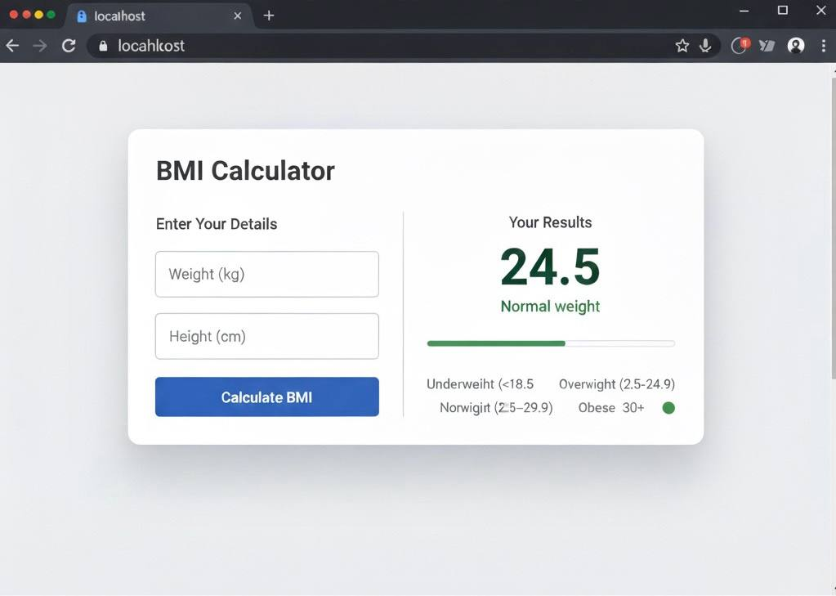

Figure 19: BMI Flask Form UI

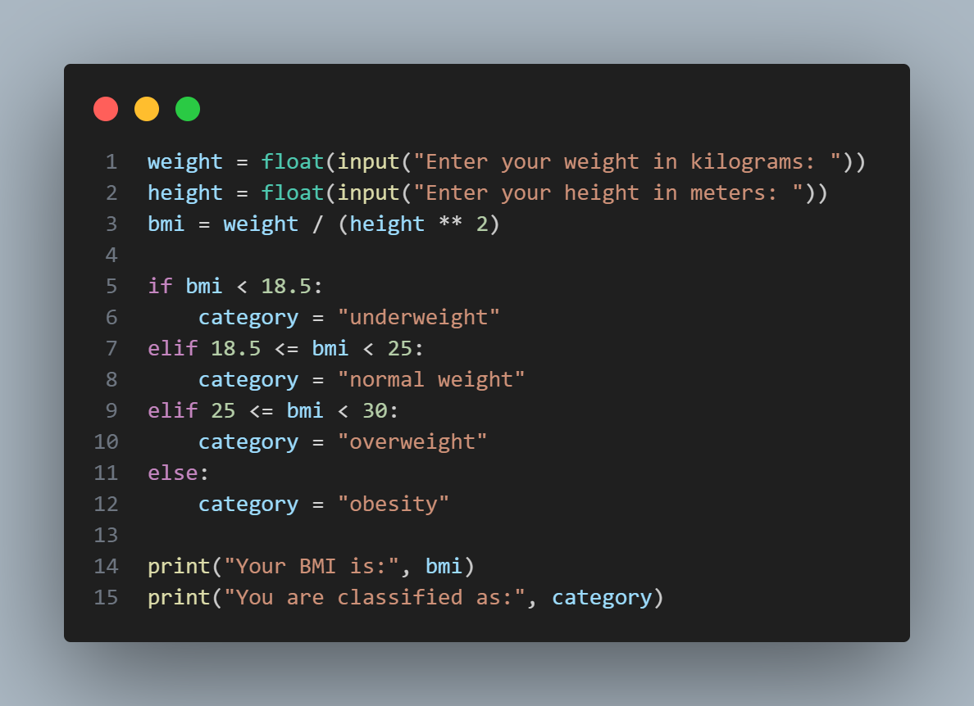

Figure 20: BMI Calculator code

**To-Do App (Frontend + simple JSON backend)**

**Objective:**  
Practice CRUD operations, DOM manipulation and persistent storage with a minimal web app.

**Tech / Tools:**  
HTML/CSS, JavaScript (vanilla), lightweight Node/Express endpoint for persistence (or localStorage for simpler builds).

**Implementation & Features:**

* Frontend allowed users to add, edit, delete and mark items as complete.
* Implemented event delegation for efficient list handling, and used localStorage for a no-server demo; later wired to a simple Express route (POST /todos, GET /todos) for persisted demos.
* Added simple CSS for responsive layout and small UX touches (focus states, accessible labels).

**Testing & Validation:**

* Manual tests for add/edit/delete flows and persistence across reloads.
* Edge-case checks: duplicated titles, very long text, empty submissions.

**Lessons learned:**

* The value of small reusable components and handling focus/keyboard accessibility.
* How an API-backed persistence layer (even a tiny one) dramatically improves demo credibility.

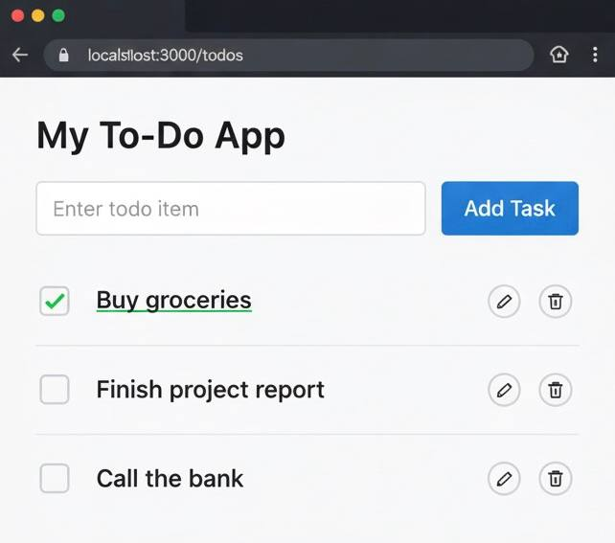

Figure 21: Todo web UI

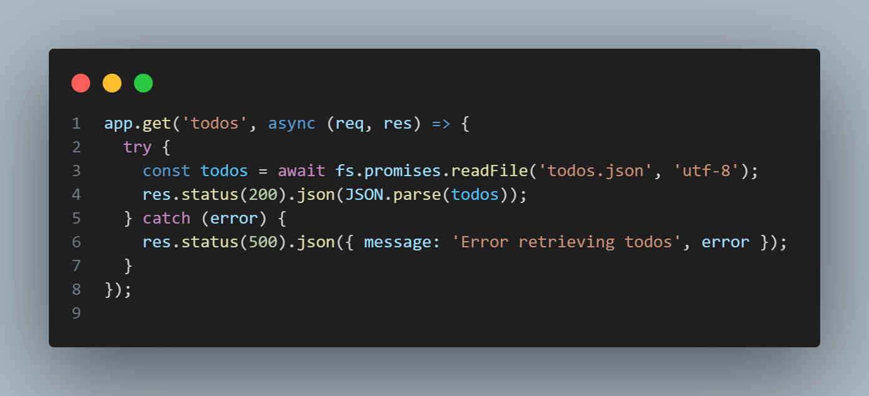

Figure 22: Todo fetch snippet

**3.2.3 Final Notes on Mini-Projects**

Collectively, the mini-projects provided:

* Continued practice of the full development cycle: design → implement → test → deploy.
* Opportunities to try different persistence models (file vs DB), interaction patterns (polling vs push), and lightweight deployment (Vercel/Render or simple GitHub Pages).
* Real examples of how small, well-tested utilities can save time and improve workflow in an IT unit.

# CHAPTER FOUR

## ****4.1 Hardware Tasks & PC Assembly****

During my SIWES training, I participated in multiple hardware-focused practical sessions that strengthened my understanding of computer components, system assembly procedures, diagnostic techniques, and routine maintenance activities. These hands-on exercises provided me with real exposure to how physical computer systems are built, configured, and restored when faults arise.

**COMPONENT IDENTIFICATION**

One of the first practical exercises involved identifying and studying the major components inside a personal computer (PC). Each component was physically examined, detached (where appropriate), and reinstalled to understand its function and placement within the system.

**Components Studied:**

* **Central Processing Unit (CPU):**  
  The CPU was identified as the primary processing unit responsible for executing program instructions. We learned how to handle it safely and the importance of using thermal paste between the CPU and its heat sink to ensure proper heat dissipation.
* **Random Access Memory (RAM):**  
  Different RAM types (DDR2, DDR3, DDR4) were examined, including their notch alignment and speed variations. We practiced inserting RAM modules into their slots and discussing how memory affects system performance.
* **Hard Drives (HDD and SSD):**  
  Both mechanical hard drives (HDDs) and solid-state drives (SSDs) were analyzed. We compared speed, durability, and interface types (SATA, NVMe) and learned how to mount and connect them properly.
* **Power Supply Unit (PSU):**  
  The PSU was studied as the hardware that provides regulated power to the entire system. We identified connectors such as the 24-pin ATX connector, 4/8-pin CPU connector, SATA power cables, and PCI-E connectors.
* **CMOS Battery:**  
  We examined the role of the CMOS battery in retaining BIOS settings. Removing it was one of the methods taught for resetting the BIOS during troubleshooting.

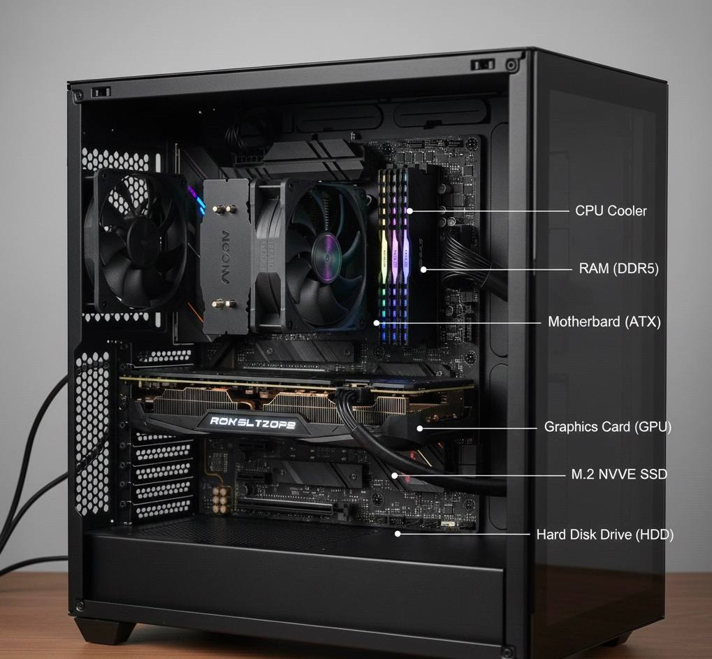

Figure 23: Internal PC Components

**Assembly Procedures and Tools Used**

We practiced assembling a desktop computer from scratch, beginning with an empty case and individual components. This exercise taught me how to follow structured procedures and use standard hardware tools safely.

**Tools Used**

* Phillips screwdrivers
* Anti-static wrist strap
* Thermal paste
* Pliers and cable ties
* Isopropyl alcohol (for cleaning old thermal paste)

**Assembly Procedure**

1. **Preparing the case:**  
   Removing side panels and ensuring proper standoff screws were in place for the motherboard.
2. **Mounting the motherboard:**  
   Carefully aligning the board with standoffs and securing it with screws.
3. **Installing the CPU:**  
   Opening the socket lever, placing the CPU according to the marker, applying thermal paste, and attaching the heat sink.
4. **Installing RAM:**  
   Inserting modules into DIMM slots until they locked into place.
5. **Installing storage drives:**  
   Mounting HDD/SSD units in drive bays and connecting them with SATA data and power cables.
6. **Connecting the PSU:**  
   Distributing power connectors to the motherboard, CPU slot, storage drives, and case fans.
7. **Front-panel wiring:**  
   We discussed the F-Panel pins, including the **Power Switch**, **Reset Switch**, **HDD LED (+/-)**, and **Power LED**. Proper alignment was practiced to ensure that the system could power on correctly.
8. **Final boot test:**  
   Verifying that the system POSTed successfully and checking connected peripherals.

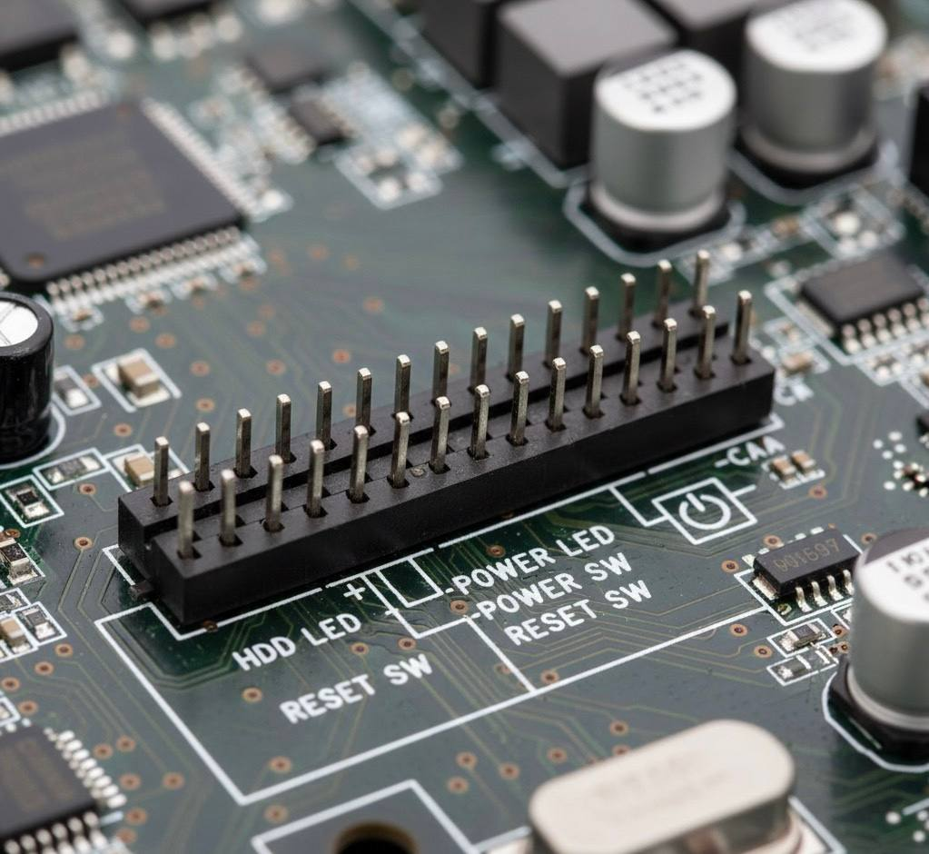

Figure 24: Motherboard F-Panel Pin

**Troubleshooting Common Faults (Beep Codes, Burnt Components)**

Troubleshooting sessions taught us how to diagnose and fix common PC issues using both visual inspection and POST (Power-On Self-Test) feedback.

**Key Troubleshooting Concepts**

* **Beep Codes:**  
  We learned that repeated or patterned motherboard beeps indicate errors.  
  Examples include:
  + Continuous beeping → RAM error
  + One long, three short beeps → GPU error
  + No beeps → Possible PSU or motherboard failure
* **Burnt Components:**  
  We performed physical inspection of motherboards to identify burnt capacitors, damaged ICs, or corroded components. This included looking for bulging capacitors, burn marks, and smell of overheating.
* **CMOS Reset:**  
  If the system refused to boot or displayed BIOS errors, we practiced resetting the BIOS by:
  + Removing and reinserting the CMOS battery
  + Using motherboard jumpers to clear CMOS
* **Overheating:**  
  Improper or dried thermal paste was identified as a common cause of CPU overheating. We practiced cleaning old paste and reapplying new thermal compound.
* **Boot/Shutdown Faults:**  
  Systems that booted and shutdown mid-way were diagnosed as potential OS-related issues or failing storage drives.

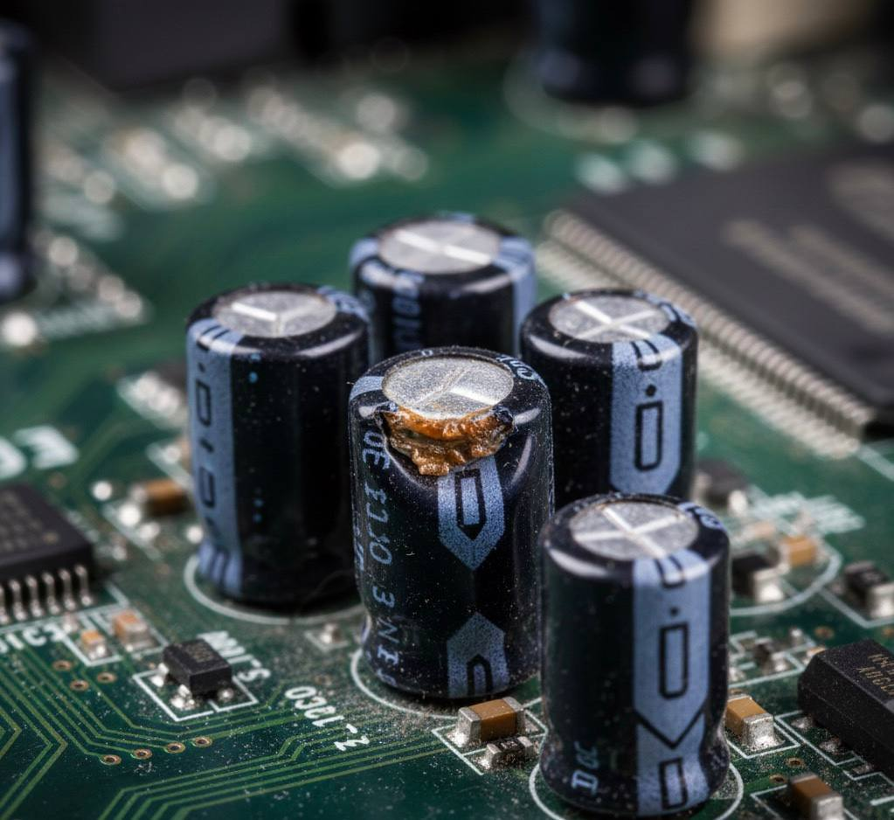

Figure 25: Bulging Capacitors

## ****4.2 Networking Practicals****

Networking practicals formed an important part of my SIWES training, giving me hands-on experience with fundamental network concepts, common topologies, essential command-line tools, and real troubleshooting processes used in everyday IT operations. These sessions exposed me to how devices communicate, how networks are structured, and how basic diagnostic tools help identify or resolve connectivity issues.

**Basic Network Topologies**

During the networking lessons, we explored the different network topologies and their real-world applications. Each topology was studied using diagrams, physical examples where possible, and practical explanations of where they are deployed.

**Network Topologies Studied**

* **Local Area Network (LAN):**  
  Covers a small geographical area such as a home, office, or school lab. It was used to show how multiple PCs in a lab can share resources like printers and storage.
* **Wide Area Network (WAN):**  
  Extends across large geographical regions. We compared WANs to global service providers (ISPs) and discussed how the internet itself is a large WAN.
* **Personal Area Network (PAN):**  
  A small network around a single user, typically involving phones, Bluetooth headsets, and wearable devices. Demonstrated with phone-to-laptop connections.
* **Metropolitan Area Network (MAN):**  
  Covers cities or large campuses. We discussed typical use cases such as university network coverage or telecommunication systems.
* **Wireless LAN (WLAN):**  
  A variation of LAN using Wi-Fi. Wireless access points were examined to show how networks can be extended without cables.

**Lab Exercises Conducted**

* Observation of how multiple systems communicate within a LAN.
* Identifying network hardware such as routers, switches, access points, and NICs.
* Mapping simple network diagrams showing how devices connect.

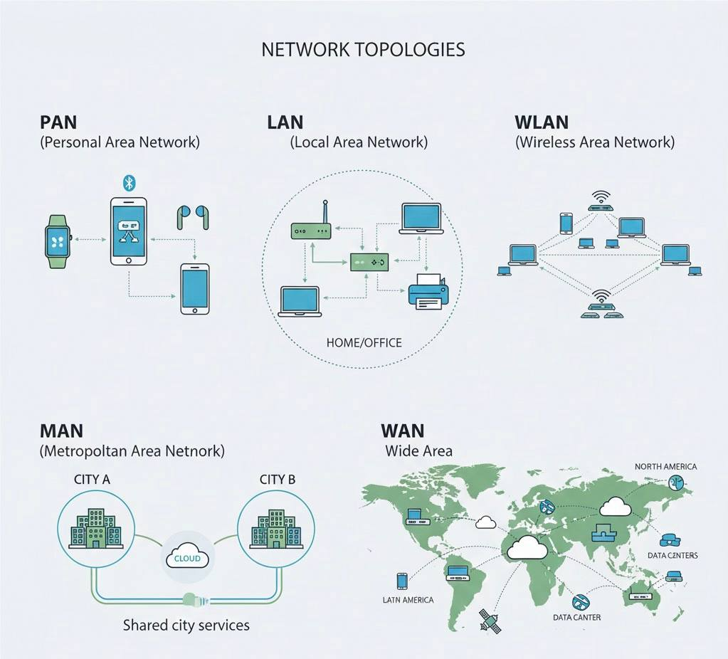

Figure 26: Network Topologies

**Network Tools Used (**ifconfig**,** ping**,** telnet**,** nc**) and Practicals**

We also worked with several command-line networking tools commonly used to inspect network configurations, test connectivity, and debug services.

**Tools Practiced**

* **ifconfig (Interface Configuration):**  
  Used to display network interface information such as IP addresses, MAC addresses, and link status.  
  We used it to verify whether a system was properly assigned an IP and connected to the correct network.
* **ping:**  
  A connectivity testing tool that uses ICMP packets.  
  We used it to confirm if a device or website was reachable, and to interpret packet loss and latency.
* **telnet:**  
  Used to test if a specific port on a remote server is open.  
  Demonstrated by checking which services were running on local machines or external test servers.
* **nc (Netcat):**  
  A powerful networking utility used for port scanning, testing custom connections, or transferring data.  
  We used it to:
  + Create simple client-server socket communication
  + Check open ports on localhost
  + Send and receive raw text over the network

**Practical Exercises**

* Checking network status of a lab computer using ifconfig.
* Pinging internal devices and public websites to measure reachability and latency.
* Using telnet and nc to confirm whether specific services were running on certain ports.
* Simulating simple client-server interactions using Netcat.

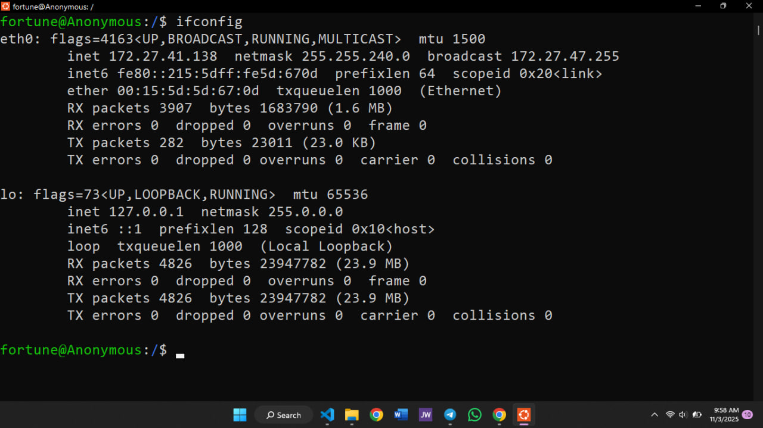

Figure 27 :ifconfig output

## ****4.3 Embedded Systems Introduction & IoT Basics****

Embedded systems and IoT technologies formed an important part of my SIWES practical sessions. These exercises introduced me to how microcontrollers work, how sensors interface with hardware, and how simple electronic prototypes are built using basic components. The sessions provided valuable exposure to low-level computing and the hardware principles behind modern smart devices.

**Microcontrollers (ESP32, Arduino) and GPIO Basics**

We began with an introduction to what an embedded system is — a combination of hardware and software designed to perform a specific function, often as part of a larger device. Microcontrollers such as the **Arduino Uno** and **ESP32** were used to demonstrate how embedded devices process inputs and control outputs.

**Microcontrollers Studied**

* **Arduino Uno:**  
  A popular microcontroller based on the ATmega328P chip. Easy to use and suitable for beginners.  
  Features include digital/analog pins, PWM support, and built-in libraries.
* **ESP32:**  
  A more advanced microcontroller with built-in Wi-Fi and Bluetooth capabilities, commonly used in IoT devices.  
  Includes many GPIO pins, support for serial communication, and low-power modes.

**GPIO Concepts (General Purpose Input/Output)**

We studied how GPIO pins allow microcontrollers to communicate with external components:

* **Digital pins:** handle HIGH/LOW signals (1 or 0).
* **Analog pins:** read varying sensor values (0–1023 on Arduino).
* **PWM pins:** simulate analog output for dimming lights or controlling motors.

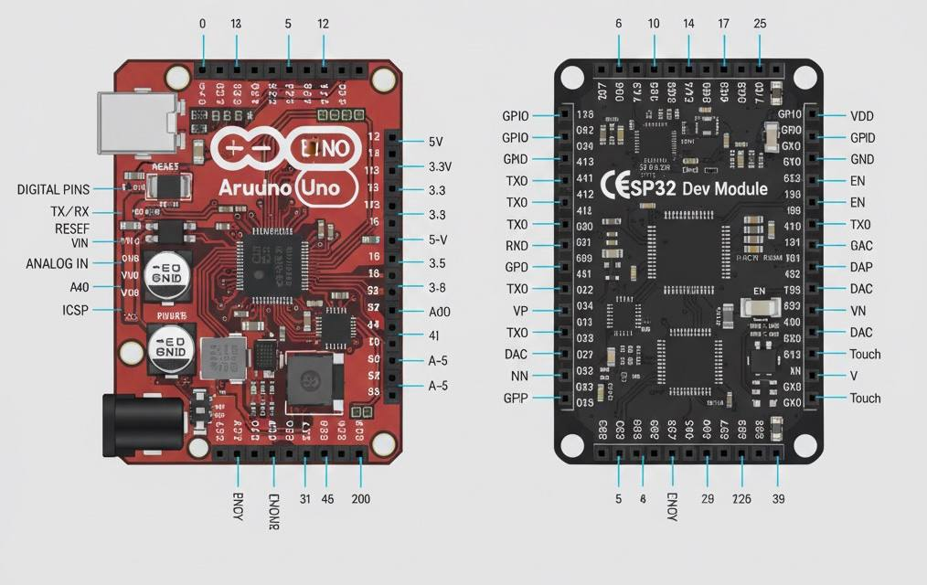

Figure 28: Arduino Uno and ESP32 pinouts

**Simple Prototypes**

Hands-on exercises helped reinforce how microcontrollers interact with electronic components. We built and tested small embedded prototypes that demonstrated real input/output operations.

**LED Blink Program**

This is the classic introductory embedded task where an LED is connected to a GPIO pin and programmed to blink at timed intervals.

**Steps performed:**

1. Connected an LED to a digital pin through a resistor.
2. Wrote a basic program using Arduino-style syntax.
3. Uploaded the code to the board using USB.
4. Verified timing by watching the LED blink every two seconds.

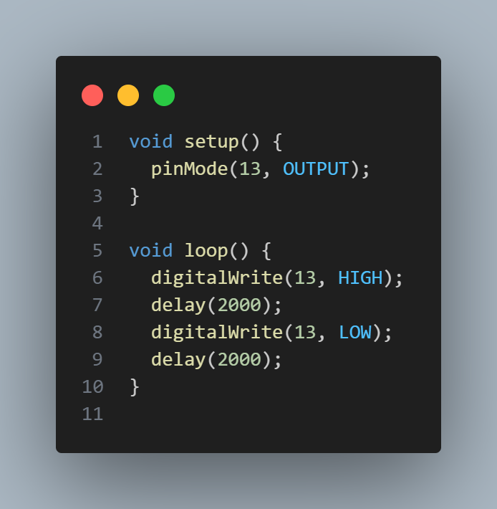

Figure 29: LED Blink Program

## ****4.4 System Maintenance & Security Basics****

System maintenance and basic security practices were an essential part of my SIWES training, providing me with practical knowledge on how to ensure the smooth operation, safety, and reliability of computer systems. These sessions helped me understand how routine checks, updates, and diagnostic procedures prevent system failures and protect computers from common threats.

**Routine System Maintenance**

We learned the importance of carrying out regular maintenance to improve performance and extend the lifespan of computer systems. The key maintenance procedures practiced included:

* **Cleaning Hardware Components:**  
  Dust was removed from fans, heat sinks, and internal components to prevent overheating and ensure proper airflow.
* **Updating Operating Systems and Drivers:**  
  Regular updates were emphasized to improve system stability, fix bugs, and patch security vulnerabilities.
* **Disk Management:**  
  Tools such as disk cleanup and defragmentation (for HDD systems) were used to improve storage efficiency and speed.
* **Checking System Logs:**  
  System logs and event viewers were examined to identify unusual activities, failed processes, or hardware warnings early.

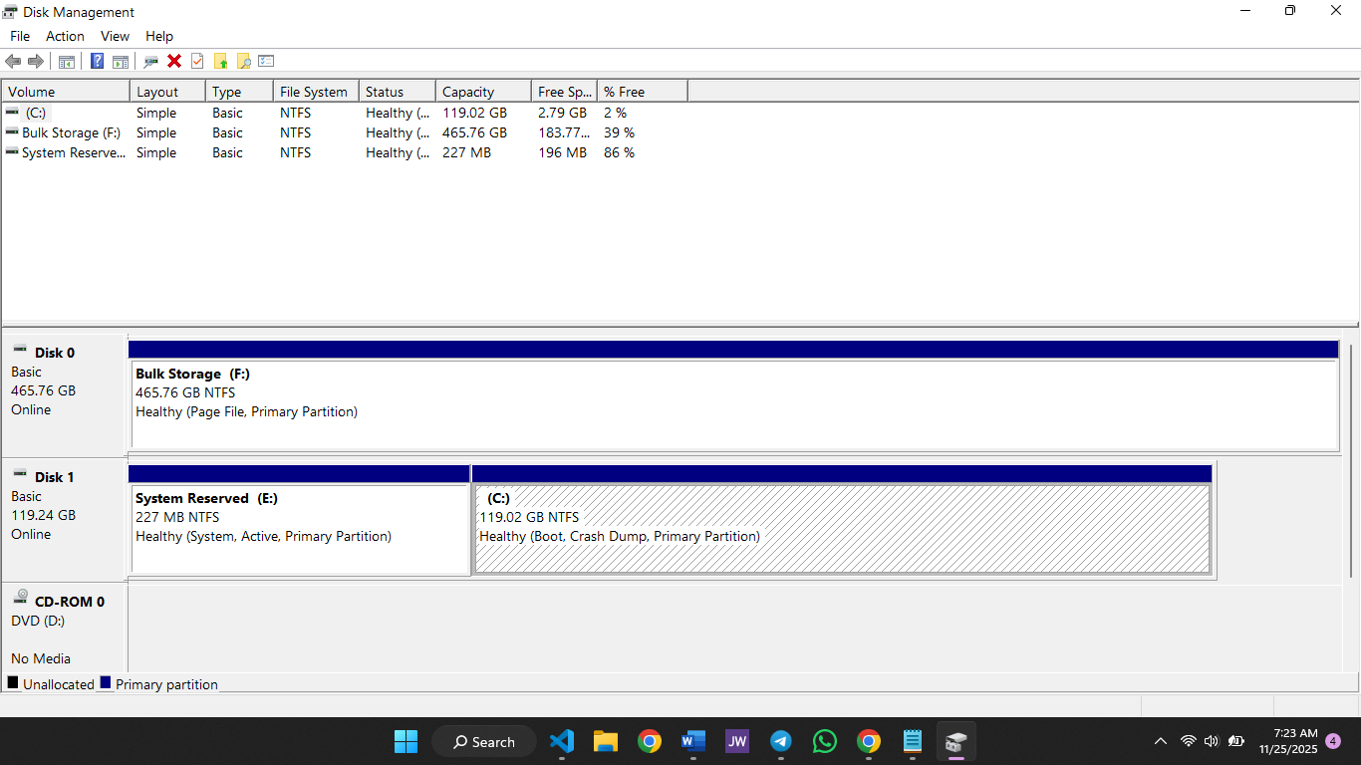

Figure 30: Disk Management Tool

**Basic Security Practices Learned**

Security basics were also covered to help protect systems from unauthorized access, malware, and other threats. These principles form the foundation of safeguarding IT environments.

**Key Security Concepts**

* **Password Security:**  
  Emphasis was placed on using strong passwords, enabling account lockout after repeated failures, and avoiding password reuse.
* **Software Verification:**  
  Installing software only from trusted sources and verifying installers to reduce malware risk.
* **Resetting BIOS (via CMOS):**  
  Removing the CMOS battery or using jumper pins to reset BIOS was demonstrated as a recovery method for forgotten passwords or corrupted settings.
* **Firewall Awareness:**  
  We learned how firewalls help control inbound and outbound traffic and prevent unauthorized access.
* **Safe Internet Practices:**  
  Avoiding insecure websites, not downloading unauthorized files, and recognizing phishing patterns.

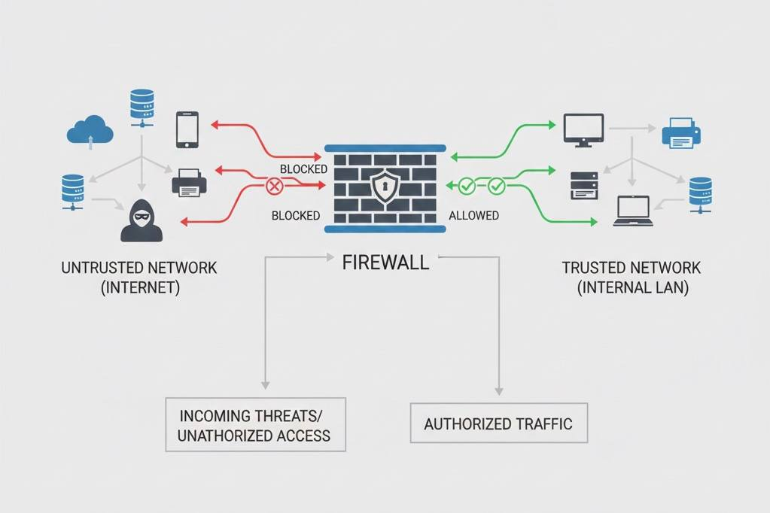

Figure 31: Firewall Functions

**Physical Safety & Handling Procedures**

Practical safety measures were emphasized during hardware operations to prevent accidents and protect components.

**Important Safety Behaviours**

* Using anti-static wrist straps to prevent electrostatic discharge (ESD).
* Disconnecting power before opening a system case.
* Avoiding metal tools near powered circuits.
* Properly handling sensitive components like CPUs and RAM without touching the contact pins.

These safety habits helped reduce the risk of hardware damage and ensured proper laboratory operation.

# **CHAPTER FIVE**

## ****5.1 Challenges Faced****

Throughout my six-month SIWES program, I experienced several technical and non-technical challenges that significantly shaped my growth as a developer.

**1. Debugging complex errors and hidden bugs.**  
A major challenge during the training was debugging issues that were not immediately visible. Many bugs arose from small mistakes such as a missing semicolon in JavaScript, misspelling a function name, incorrect import paths, or mixing up HTML element IDs. One of the most difficult issues I encountered was when building backend applications: the server would crash silently due to a logic error or an unhandled promise rejection, making it hard to trace.  
For the real-time chat project, socket-related bugs—especially users disconnecting unexpectedly or duplicate events firing—required deep investigation. I often had to log socket events manually, inspect payloads, and revisit code execution flow before discovering the root cause.

**2. Adjusting quickly to different technologies.**  
My training covered a wide range of tools and technologies—Express, Flask, MySQL, MongoDB, Redis, Git, GitHub, Linux, React, Bootstrap, hardware systems, networking, and embedded systems fundamentals. Switching rapidly from web development to system hardware troubleshooting, then to embedded systems, and back to Python scripting was mentally demanding.  
Often, just after understanding one tool or framework, a new one was introduced. This cycle of “learn → understand → move to the next tool” was intense, but it helped me become more adaptable and confident in self-driven learning.

**3. Deployment and environment challenges.**  
Deploying projects, especially real-time applications, came with issues related to environment variables, build processes, and server behavior. Hosting the real-time chat application on Render introduced challenges such as connection timeouts, environment mismatches, and cold-start delays. These problems taught me to test my application in multiple environments, validate configurations, and understand the impact of deployment platforms on performance.

**4. Hardware and troubleshooting difficulties.**  
During hardware sessions, identifying faulty components such as damaged RAM, malfunctioning hard drives, burnt capacitors, or loose motherboard connections required careful observation. Interpreting beep codes, resetting CMOS, and troubleshooting power failures pushed me to think more like a technician rather than a programr.

**5. Balancing multiple topics at once.**  
Because the training included software engineering, networking, hardware assembly, operating systems, and embedded systems, keeping track of everything at once was a challenge. Managing notes, practicing consistently, and switching cognitive “modes” between coding and hardware tasks required strong discipline.

Despite these challenges, each obstacle contributed to a deeper level of understanding and significantly sharpened my problem-solving skills.

## ****5.2 Suggestions for Improvement of SIWES****

To improve the experience for future SIWES students, the following recommendations would be beneficial:

**1. Provide financial support.**  
Throughout my training, no financial support was received from ITF even after submitting account details. Considering transportation costs and daily expenses, early financial assistance would greatly reduce the stress students face and allow us to focus more on learning.

**2. More structured learning curriculum.**  
While the training was rich, a more organized weekly learning plan—including expected outcomes, tools to be mastered, and mini-projects—would make the learning experience more coordinated and less overwhelming.

**3. Access to more development resources.**  
Providing students with access to online learning platforms, documentation bundles, or curated learning materials would make the self-study process easier and more effective.

**4. More hands-on assessments.**  
Encouraging students to complete small weekly tasks or build mini-projects (e.g., Python utilities, SQL exercises, small React apps) would reinforce learning and provide measurable progress.

**5. Better integration between software and hardware training.**  
Since many computer science students focus heavily on software, the hardware modules could include more practical demonstrations, supervised lab sessions, and real-life troubleshooting scenarios to improve competence.

## ****5.3 Conclusion****

My SIWES training has been one of the most transformative experiences in my academic journey. The six-month program exposed me to practical, real-world applications of concepts from courses such as Introduction to Programming, Data Management, Operating Systems, System Analysis and Design, and Networking.

I built foundational and advanced skills in:

* Full-stack web development
* Databases (SQL & NoSQL)
* Realtime systems using Socket.IO
* Python scripting and functional programming
* Linux commands and system navigation
* Hardware troubleshooting and PC assembly
* Networking tools and topologies
* IoT basics and simple microcontroller programming

Working on my major project—the real-time chat application—allowed me to experience modern development workflows, async programming, state management, server deployment, and debugging realtime features. Smaller projects such as the BMI calculator, SQL scripting, React components, and Linux shell tasks helped reinforce what I learned.

My training also strengthened my soft skills: time management, communication, patience, resilience, and learning independently under pressure. It reaffirmed my passion for software engineering and helped me understand the direction I want my career to take.

Overall, the SIWES program has equipped me with valuable technical competencies and real-world experience, preparing me for more advanced roles in software engineering and giving me a strong foundation for future growth.